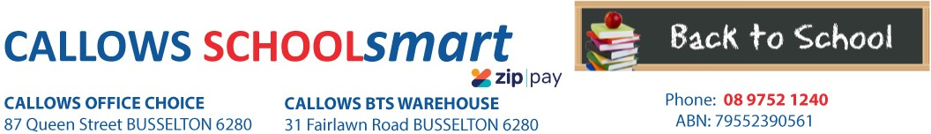

MARGARET RIVER PRIMARY SCHOOL YEAR 6 2023

Students Name............................................... Phone.....................................

Parents Name.......................................... Email........................................................

Item Code | Please tick required items | Qty Price ea Subtotal
PERSONAL ITEMS LIST
CALCULATOR MARBIG COMPACT DESKTOP 8 DIGIT
CARD PANTHER 210gsm 510*640mm ASSTD BRIGHT
COLS - Single Sheets
97640
2777
1 12.10
4 1.50
$12.10
$6.00

CLIPFOLDER GNS A4 PVC ASST 713-A CLIPFOLDER MARBIG INSERT W/EXP POCKET WHITE 4450008 COMPASS MICADOR 325 H/SELL B/CARD CMM324
1 3.50 $3.50
1 11.65 $11.65
1 1.60 $1.60

DOCUMENT WALLET MARBIG PP F/C VELCRO
W/GUSSET TEAL
2011004
4 1.35 $5.40

ERASER FABER CASTELL LARGE DUST FREE WITH SLEEVE 82-187177 EXPANDING FILE STAT A4 13 POCKET STAT ASST COLOURS 74331 GLUE STICK RAZORLINE 36G 7123
HEADPHONES VERBATIM with VOLUME CONTROL 41645

HIGHLIGHTER FABER TEXTLINER ICE WLT4 57-4802-04
MARKER ARTLINE 70 PERM 1.5mm BULLET NIB BLACK 107001 MARKER FABER PROJECT/SKETCH PK 12 50-155112
2 0.75 $1.50
1 10.40 $10.40
3 1.10 $3.30
1 14.90 $14.90
1 5.00 $5.00
2 3.25 $6.50
1 2.30 $2.30

MATHOMAT STENCIL TEMPLATE V2 W/120Page

ILLUSTRATED STUDENT BOOK
NOTEBOOK STAT A5 60GSM 7MM RULING PP COVER BLACK 200PG
65491

48056
1 29.50 $29.50

1 2.25 $2.25

PEN ARTLINE 200 FINE 0.4mm BLACK 120001

PEN BIC BP CRISTAL MED BLACK 04241
PEN BIC BP CRISTAL MED BLUE 04243
PEN BIC BP CRISTAL MED RED 04242 PENCIL CASE MARBIG 340*170mm 1 zip TARTAN JUMBO 974411 PENCIL COLOURED STAEDTLER NORIS CLUB 12`S 185 C12
PENCIL GRAPHITE GOLDFABER 1221 HB 11-112500 PROTRACTOR CELCO 10cm 180 DEG`S HALF CIRCLE 0344540 RULER MARBIG 30cm CLEAR PLASTIC 975317B
4 2.50 $10.00
4 0.40 $1.60
4 0.40 $1.60
4 0.40 $1.60
1 2.65 $2.65
1 3.80 $3.80
6 0.60 $3.60
1 0.30 $0.30
1 0.50 $0.50

SCISSORS WESTCOTT 178mm Suitable for
RIGHT/LEFT HANDED Asstd Cols
Suitable for left and right handed students.

142-A
1 2.10 $2.10

SHARPENER MARBIG METAL SILVER SINGLE HOLE 975201 SKETCH BOOK SPIRAX A4 100 Page SKETCH-IT 56981 SKETCH BOOK SPIRAX P534 PP A4 40 PAGES BLK S/O 5606800 USB GOLDEN MARS 8GB DSUSB8
1 0.40 $0.40
1 0.00 $8.50
1 3.65 $3.65
1 9.80 $9.80

WHITEBOARD MARKER ARTLINE 500A 2mm BULLET NIB BLACK
WHITEBOARD MARKER ARTLINE 500A 2mm BULLET NIB BLUE

SUBTOTAL
150001

150003
2 3.95 $7.90

2 3.95 $7.90

$181.80

HANDLING/PACKAGING FEE
H/PK
1 3.00
$3.00
Mandatory fee for all pre-packed orders.
PARENTS TO SUPPLY:
2 x Large Boxes of Tissues
1 x Old Shirt For Art/Craft

Item Code Comment Qty Price ea Subtotal
LIBRARY BAG AVAILABLE FRONT OFFICE

DELIVERY FEE Delivery 1 7.95 $7.95
ORDER TOTAL:

PLEASE NOTE: To guarantee prices quoted and supply of all items,please ensure orders are placed by due date.
PLEASE RETAIN YOUR RECEIPTS AS PROOF OF PURCHASE and/or PAYMENT OF CONTRIBUTIONS. ORDER ONLINE OR BACK-TO-SCHOOL PRICING/ITEMS AVAILABLE IN STORE from 1st of January 2023

OFFICE USE ONLY:

Date:....................... Amount Paid:..............................Sales Assistant:......................................... ZIPPay YES / NO

