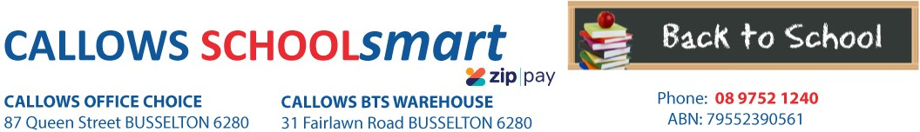

MARGARET RIVER PRIMARY SCHOOL YEAR 4 2023

Students Name............................................... Phone.....................................

Parents Name.......................................... Email........................................................

Item Code | Please tick required items | Qty Price ea Subtotal
PERSONAL ITEMS LIST
CALCULATOR MARBIG COMPACT DESKTOP 8 DIGIT
DISPLAY BOOK MARBIG A3 20 PAGE PORTRAIT INSERT COVER BLACK
97640
2008802
1 12.10
1 6.50
$12.10
$6.50

DISPLAY BOOK MARBIG A4 20 PAGE REFILLABLE YELLOW 2007005 1 1.65 $1.65

DOCUMENT WALLET MARBIG PP F/C VELCRO W/GUSSET CLEAR
DOCUMENT WALLET MARBIG PP F/C VELCRO W/GUSSET BLUE
2011012

2011001
1 1.35 $1.35

1 1.35 $1.35

DOCUMENT WALLET MARBIG PP F/C VELCRO W/GUSSET RED 2011003 1 1.35 $1.35

DOCUMENT WALLET MARBIG PP F/C VELCRO W/GUSSET YELLOW
2011005
1 1.35 $1.35

ERASER FABER CASTELL LARGE DUST FREE WITH SLEEVE 82-187177 GLUE STICK RAZORLINE 36G 7123
HEADPHONES VERBATIM with VOLUME CONTROL 41645
HIGHLIGHTER FABER TEXTLINER ICE WLT4 57-4802-04
MARKER FABER PROJECT/SKETCH PK 12 50-155112
PEN ARTLINE 200 FINE 0.4mm BLACK 120001
PEN BIC BP CRISTAL MED RED 04242
PENCIL COLOURED STAEDTLER NORIS CLUB 12`S 185 C12
PENCIL GRAPHITE FABER 1111 HB Box 12 12 1111-HBBX12
RULER CELCO 30cm WOODEN UNPOLISHED 0321740
4 0.75 $3.00
4 1.10 $4.40
1 14.90 $14.90
1 5.00 $5.00
1 2.30 $2.30
4 2.50 $10.00
1 0.40 $0.40
1 3.80 $3.80
2 3.00 $6.00
2 0.65 $1.30

SCISSORS WESTCOTT 178mm Suitable for RIGHT/LEFT HANDED Asstd Cols
Suitable for left and right handed students.
142-A
1 2.10 $2.10

SHARPENER MAPED SHAKER 2 HOLE with Catcher 8534755 SKETCH BOOK SPIRAX P534 PP A4 40 PAGES BLK S/O 5606800 WHITEBOARD MARKER STAT 2.0mm ASSTD WLT4 48009

Subtotal
2 1.30 $2.60
1 3.65 $3.65
1 2.80 $2.80

$87.90

HANDLING/PACKAGING FEE
H/PK
1 3.00
$3.00
Mandatory fee for all pre-packed orders.
PARENTS TO SUPPLY:
1 x Box of Tissues
LIBRARY BAG AVAILABLE FROM FRONT OFFICE

DELIVERY FEE Delivery 1 7.95 $7.95
ORDER TOTAL:

PLEASE NOTE: To guarantee prices quoted and supply of all items,please ensure orders are placed by due date.
PLEASE RETAIN YOUR RECEIPTS AS PROOF OF PURCHASE and/or PAYMENT OF CONTRIBUTIONS. ORDER ONLINE OR BACK-TO-SCHOOL PRICING/ITEMS AVAILABLE IN STORE from 1st of January 2023

OFFICE USE ONLY:

Date:....................... Amount Paid:..............................Sales Assistant:......................................... ZIPPay YES / NO

