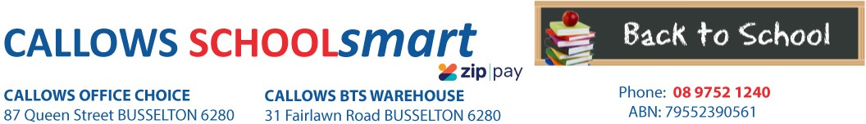

MARGARET RIVER PRIMARY SCHOOL YEAR 3 2023

Students Name............................................... Phone.....................................

Parents Name.......................................... Email........................................................

Item Code | Please tick required items | Qty Price ea Subtotal
PERSONAL ITEMS LIST
CALCULATOR MARBIG COMPACT DESKTOP 8 DIGIT
CARD LIGHTWEIGHT A4 160gsm ASSTD BRIGHT SINGLE SHEET
97640
4487
1 12.10
10 0.50
$12.10
$5.00

Pre-packed orders will be delivered to the school for distribution
CLIPFOLDER GNS A4 PVC ASST 713-A 1 3.50 $3.50
DISPLAY BOOK MARBIG A4 20 PAGE REFILLABLE GREEN 2007004 1 1.65 $1.65
DISPLAY BOOK MARBIG A4 20 PAGE REFILLABLE YELLOW 2007005 1 1.65 $1.65
DISPLAY BOOK MARBIG A4 20 PAGE REFILLABLE RED 2007003 1 1.65 $1.65
DOCULOPE DOCUMENT WLT MARBIG A4 BUTTON BLUE 2015001 2 0.70 $1.40

DOCUMENT WALLET MARBIG PP F/C VELCRO W/GUSSET TEAL
DOCUMENT WALLET MARBIG PP F/C VELCRO W/GUSSET YELLOW
2011004

2011005
1 1.35 $1.35

1 1.35 $1.35

DOCUMENT WALLET MARBIG PP F/C VELCRO W/GUSSET RED 2011003 HEADPHONES SHINTARO (Volume Control) SERIES 101 90904 ERASER FABER CASTELL LARGE DUST FREE WITH SLEEVE 82-187177 GLUE STICK RAZORLINE 36G 7123
HIGHLIGHTER FABER TEXTLINER FROSTED GREEN 57-154663 HIGHLIGHTER FABER TEXTLINER FROSTED YELLOW 57-154607 PEN ARTLINE SUPREME FINELINER 0.4mm BLACK 102101
PEN BIC BP CRISTAL MED RED 04242 PEN CONNECTOR MARKER FABER ASSTD COLS PKT 12 11-155570 PENCIL CASE MARBIG 340*170mm 1 zip TARTAN JUMBO 974411 PENCIL COLOURED STAEDTLER NORIS CLUB 12`S 185 C12
PENCIL GRAPHITE FABER 1111 HB Box 12 12-1111-HBBX12
RULER MARBIG 30cm CLEAR PLASTIC 975317B
1 1.35 $1.35
1 9.85 $9.85
6 0.75 $4.50
3 1.10 $3.30
1 1.15 $1.15
1 1.15 $1.15
1 1.20 $1.20
2 0.40 $0.80
2 4.65 $9.30
1 2.65 $2.65
2 3.80 $7.60
2 3.00 $6.00
2 0.50 $1.00

SCISSORS WESTCOTT 178mm Suitable for RIGHT/LEFT HANDED Asstd Cols

Suitable for left and right handed students.
142-A
1 2.10 $2.10

SHARPENER MAPED SHAKER 2 HOLE with Catcher
SKETCH BOOK SPIRAX P534 PP A4 40 PAGES BLK S/O
WHITEBOARD MARKER ARTLINE 509A 5mm CHISEL NIB BLUE
8534755
5606800
150903A
2 1.30
1 3.65
1 4.55
$2.60
$3.65
$4.55
TEXTBOOK
KLUWELL MY HOME READING ORANGE LEVEL Senior
37341
1 5.50
$5.50

Subtotal $97.90

HANDLING/PACKAGING FEE
H/PK
1 3.00
$3.00
Qty Price ea Subtotal
Comment
Code
Item
Mandatory fee for all pre-packed orders.
PLEASE SEND IN ALL PERSONAL ITEMS ON DAY 1 OF THE SCHOOL YEAR
PARENTS TO SUPPLY:
2 x Large Box of Tissues:
1 x Snap Lock Bag - Sandwich 20cm x18cm
1 x Snap Lock Bag - Medium Size 22cm x 25cm
LIBRARY BAG AVAILABLE FROM FRONT OFFICE

DELIVERY FEE Delivery 1 7.95 $7.95
ORDER TOTAL:

PLEASE NOTE: To guarantee prices quoted and supply of all items,please ensure orders are placed by due date.
PLEASE RETAIN YOUR RECEIPTS AS PROOF OF PURCHASE and/or PAYMENT OF CONTRIBUTIONS. ORDER ONLINE OR BACK-TO-SCHOOL PRICING/ITEMS AVAILABLE IN STORE from 1st of January 2023

OFFICE USE ONLY:

Date:....................... Amount Paid:..............................Sales Assistant:......................................... ZIPPay YES / NO

