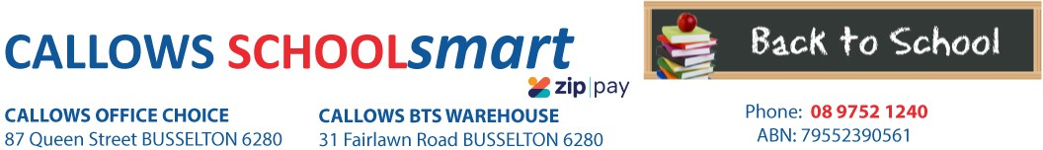

MARGARET RIVER PRIMARY SCHOOL YEAR 2 2023

Students Name............................................... Phone.....................................

Parents Name.......................................... Email........................................................

Item Code | Please tick required items | Qty Price ea Subtotal
PERSONAL ITEMS LIST

CALCULATOR MARBIG COMPACT DESKTOP 8 DIGIT 97640 CRAYONS TEXTA ZOOM PK 12 49875 DISPLAY BOOK MARBIG A4 20 PAGE REFILLABLE DK BLUE 2007027
1 12.10 $12.10
2 6.45 $12.90
1 1.65 $1.65

DOCUMENT WALLET MARBIG PP F/C VELCRO
W/GUSSET BLUE
2011001
4 1.35 $5.40

DOCUMENT WALLET MARBIG PP F/C VELCRO W/GUSSET RED
DOCUMENT WALLET MARBIG PP F/C VELCRO W/GUSSET YELLOW
2011003
2011005
2 1.35
2 1.35
$2.70
$2.70

ERASER FABER CASTELL LARGE DUST FREE WITH SLEEVE 82-187177 GLUE STICK RAZORLINE 36G 7123
HEADPHONES VERBATIM with VOLUME CONTROL 41645

HIGHLIGHTER DELI WALLET OF 6 ASST COLOURS 37235
PEN ARTLINE 200 FINE 0.4mm BLACK 120001

PEN BIC BP CRISTAL MED RED 04242 PEN CONNECTOR MARKER FABER ASSTD COLS PKT 12 11-155570
4 0.75 $3.00
6 1.10 $6.60
1 14.90 $14.90
1 3.75 $3.75
1 2.50 $2.50
2 0.40 $0.80
2 4.65 $9.30

PENCIL CASE MICADOR 375*264mm NAME 2 zip

ASSTD COLS
MPCN5A-B
1 5.80 $5.80

PENCIL COLOURED RAZORLINE PK 12 38023
RULER CELCO 30cm WOODEN UNPOLISHED 0321740
PENCIL GRAPHITE FABER 1111 HB Box 12 12-1111-HBBX12
2 2.00 $4.00
1 0.65 $0.65
2 3.00 $6.00

SCISSORS WESTCOTT 178mm Suitable for RIGHT/LEFT HANDED Asstd Cols

Suitable for left & right handed

142-A
1 2.10 $2.10

SHARPENER MARBIG METAL SILVER 2 HOLE
SKETCH BOOK SPIRAX P534 PP A4 40 PAGES BLK S/O
WHITEBOARD MARKER ARTLINE 577 3mm BULLET NIB ASST COLS
WHITEBOARD MARKER ARTLINE 577 3mm BULLET NIB BLACK
975202
5606800
157741
2 0.65
1 3.65
1 3.25
$1.30
$3.65
$3.25
157701
1
3.25
$3.25
TEXTBOOK

KLUWELL MY HOME READING YELLOW LEVEL Junior 37327 1 5.50 $5.50

9780648237327

$113.80

HANDLING/PACKAGING FEE
H/PK
1 3.00
$3.00
Mandatory fee for all pre-packed orders.
PARENTS TO SUPPLY: 1 x Large Boxes of Tissues
1 x Box of Zip Lock Bags Snack Size (or A4)
READING/LIBRARY BAG AVAILABLE FROM FRONT OFFICE
PLEASE SEND IN ALL PERSONAL ITEMS ON DAY 1 OF THE SCHOOL YEAR FULLY LABELLED INDIVIDUAL ITEMS.

DELIVERY FEE Delivery 1 7.95 $7.95
ORDER TOTAL:

PLEASE NOTE: To guarantee prices quoted and supply of all items,please ensure orders are placed by due date.
PLEASE RETAIN YOUR RECEIPTS AS PROOF OF PURCHASE and/or PAYMENT OF CONTRIBUTIONS. ORDER ONLINE OR BACK-TO-SCHOOL PRICING/ITEMS AVAILABLE IN STORE from 1st of January 2023

OFFICE USE ONLY:

Date:....................... Amount Paid:..............................Sales Assistant:......................................... ZIPPay YES / NO

