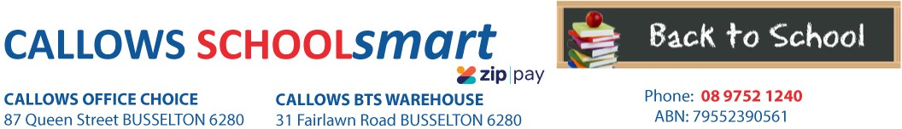

MARGARET RIVER PRIMARY SCHOOL YEAR 1 2023

Students Name............................................... Phone.....................................

Parents Name.......................................... Email........................................................

Item Code | Please tick required items | Qty Price ea Subtotal
PERSONAL ITEMS LIST

CLIPBOARD GNS A4 PVC BLACK 71391 CRAYONS MICADOR TWISTAZ COLOURFUN JUMBO 12`S CRM700 DOCULOPE DOCUMENT WLT MARBIG A3 BUTTON CLEAR 2015212 ERASER FABER CASTELL LARGE DUST FREE WITH SLEEVE 82-187177 GLUE STIC UHU RENATURE 40GM 33-00047
MESH POUCH DELI A4 ZIP ASST COLOURS 5596
HEADPHONES VERBATIM with VOLUME CONTROL 41645 MARKER ARTLINE 70 PERM 1.5mm BULLET NIB BLACK 107001 PEN CONNECTOR MARKER FABER ASSTD COLS PKT 12 11-155570 PENCIL CASE MARBIG 345*165mm NAME LGE 974398L
PENCIL COLOURED FABER JNR TRIANG GRIP PK10 16-116538-10
PENCIL GRAPHITE FABER JUNIOR GRIP WITH DOTS HB 12-116598
1 2.75 $2.75
1 7.65 $7.65
1 2.70 $2.70
4 0.75 $3.00
8 2.60 $20.80
2 2.60 $5.20
1 14.90 $14.90
1 3.25 $3.25
1 4.65 $4.65
1 3.00 $3.00
2 4.90 $9.80
12 0.60 $7.20

SCISSORS WESTCOTT 152mm Suitable for RIGHT/LEFT HANDED BLUE OR RED
Suitable for left and right handed students.
SCRAPBOOK PROTEXT 330*240mm 64Pg BLUE ANIMAL MAGIC 100gsm PP COVER
1443-A

01429
1 1.60 $1.60

6 2.65 $15.90

SHARPENER MARBIG METAL SILVER 2 HOLE
SKETCH BOOK SPIRAX P534 PP A4 40 PAGES BLK S/O
WHITEBOARD MARKER ARTLINE 500A 2mm BULLET NIB BLACK
WHITEBOARD MARKER ARTLINE 500A 2mm BULLET NIB BLUE
975202
5606800
150001
1 0.65
1 3.65
1 3.95
$0.65
$3.65
$3.95
150003
1
3.95
$3.95
TEXTBOOK
KLUWELL MY HOME READING YELLOW LEVEL Junior 37327 1 5.50 $5.50

9780957874541

SUBTOTAL $120.10
HANDLING/PACKAGING FEE
H/PK
1 3.00
$3.00
Mandatory fee for all pre-packed orders
PARENTS TO SUPPLY:
2 x Box of Tissues
1 x Large Art Shirt
LIBRARY BAG AVAILABLE FROM FRONT OFFICE
PLEASE LABEL ALL ITEMS INDIVIDUALLY, ESPECIALLY PENCILS, TEXTAS AND CRAYONS
DELIVERY FEE Delivery 1 7.95 $7.95
ORDER TOTAL:

PLEASE NOTE: To guarantee prices quoted and supply of all items,please ensure orders are placed by due date.
PLEASE RETAIN YOUR RECEIPTS AS PROOF OF PURCHASE and/or PAYMENT OF CONTRIBUTIONS. ORDER ONLINE OR BACK-TO-SCHOOL PRICING/ITEMS AVAILABLE IN STORE from 1st of January 2023

OFFICE USE ONLY:

Date:....................... Amount Paid:..............................Sales Assistant:......................................... ZIPPay YES / NO

