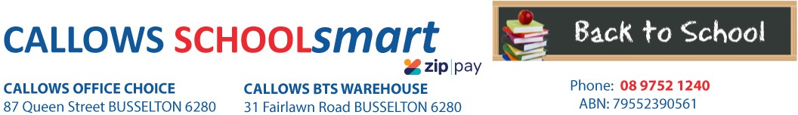

MARGARET RIVER PRIMARY SCHOOL PRE-PRIMARY 2023

Students Name............................................... Phone.....................................

Parents Name.......................................... Email........................................................

Item Code | Please tick required items | Qty Price ea Subtotal
PERSONAL ITEMS LIST

BLU TACK BOSTIK 75g
CARDBOARD PANTHER A3 200gsm ASSTD COLOURS
- SINGLE SHEET
54500
2472
1 4.40
20 0.75
$4.40
$15.00

Pre-packed orders will be delivered to the school for distribution
CLAY MODELLING EC RAINBOW 180G NON TOXIC COLOURFAST PK 12

17406 1 4.45 $4.45

DISPLAY BOOK MARBIG A4 40 PAGE REFILLABLE GREEN 2007404 DOCULOPE DOCUMENT WLT MARBIG A3 BUTTON CLEAR 2015212 GLUE STIC UHU RENATURE 40GM 33-00047
MESH POUCH DELI A4 ZIP ASST COLOURS 5596 MARKER ARTLINE 700 PERM 0.7mm BULLET NIB BLACK 170001 PEN ARTLINE 200 FINE 0.4mm BLACK 120001
PEN ARTLINE 210 MEDIUM 0.6mm BLACK 121001
2 5.10 $10.20
1 2.70 $2.70
2 2.60 $5.20
2 2.60 $5.20
1 3.25 $3.25
1 2.50 $2.50
1 2.50 $2.50

PENCIL GRAPHITE STAEDTLER NATURAL JUMBO TRIANG. PK 3
STORY BOOK SPIRAX 169 328*240mm 24mm SOLID RULED 100gsm
119N-2BBK3

56169
1 2.45 $2.45

2 3.50 $7.00

VELCRO DOTS HOOK AND LOOP PKT12 WHITE
43032
1 5.45
$5.45
SUBTOTAL $70.30
HANDLING/PACKAGING FEE
H/PK
1 3.00
$3.00
Mandatory fee for all pre-packed orders
PARENTS TO SUPPLY:
1 x Hat (compulsory and available from uniform shop)
1 x Water Bottle
LIBRARY BAG AVAILABLE FROM FRONT OFFICE
DELIVERY FEE Delivery 1 7.95 $7.95
ORDER TOTAL:

PLEASE NOTE: To guarantee prices quoted and supply of all items,please ensure orders are placed by due date.
PLEASE RETAIN YOUR RECEIPTS AS PROOF OF PURCHASE and/or PAYMENT OF CONTRIBUTIONS. ORDER ONLINE OR BACK-TO-SCHOOL PRICING/ITEMS AVAILABLE IN STORE from 1st of January 2023

OFFICE USE ONLY:

Date:....................... Amount Paid:..............................Sales Assistant:......................................... ZIPPay YES / NO

