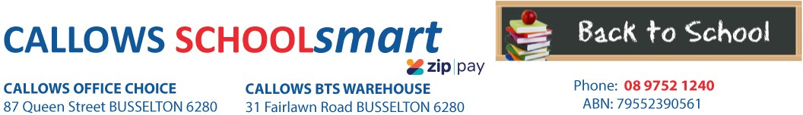

MARGARET RIVER PRIMARY SCHOOL KINDERGARTEN 2023

Students Name............................................... Phone.....................................

Parents Name.......................................... Email........................................................

Item Code | Please tick required items | Qty Price ea Subtotal
PERSONAL ITEMS LIST

Pre-packed orders will be delivered to the school for distribution
CARDBOARD PANTHER A4 200gsm ASSTD COLOURS
- SINGLE SHEETS
2340
20 0.50
$10.00
CARDBOARD PANTHER A3 200gsm ASSTD COLOURS
- SINGLE SHEET
Pre-packed orders will be delivered to the school for distribution

2472 20 0.75 $15.00

DISPLAY BOOK MARBIG A3 20 PAGE PORTRAIT INSERT COVER BLACK
DISPLAY BOOK MARBIG A4 20 PAGE REFILLABLE ASSTD COLS
2008802
1 6.50
$6.50
2007099
1
1.65
$1.65

DOCULOPE DOCUMENT WLT MARBIG A3 BUTTON CLEAR 2015212 GLUE STIC UHU RENATURE BLUE 40G 33-00005
MARKER ARTLINE 700 PERM 0.7mm BULLET NIB BLACK 170001
1 2.70 $2.70
1 2.60 $2.60
1 3.25 $3.25

SCISSORS WESTCOTT 127mm Suitable for RIGHT/LEFT HANDED BLUNT TIP BLUE
EOY TAKE HOME

SUBTOTAL
14606
1 1.50 $1.50

$43.20

HANDLING/PACKAGING FEE
H/PK
1 3.00
$3.00
Mandatory fee for all pre-packed orders
PARENTS TO SUPPLY:
1 x Box of Tissues
1 x Hat (Compulsory)
1 x Drink Bottle
DELIVERY FEE Delivery 1 7.95 $7.95
ORDER TOTAL:

PLEASE NOTE: To guarantee prices quoted and supply of all items,please ensure orders are placed by due date.
PLEASE RETAIN YOUR RECEIPTS AS PROOF OF PURCHASE and/or PAYMENT OF CONTRIBUTIONS. ORDER ONLINE OR BACK-TO-SCHOOL PRICING/ITEMS AVAILABLE IN STORE from 1st of January 2023

OFFICE USE ONLY:

Date:....................... Amount Paid:..............................Sales Assistant:......................................... ZIPPay YES / NO

